Common Cents – Fall 2015 to Spring 2016

# Energy Use and Wealth Creation

Its common ‘wisdom’ bandied about at water coolers, dinner tables, and political gatherings, that while the United States has 5 percent of the world’s population is uses 24 percent of the world’s energy. Sagely nods and enlightened shakes of the head always come in the wake of such an utterance. But what does this statistic really mean – that we are wasteful, that we take from others, what?

To the common man, this statistic indicates just how wasteful the United States is, just how predatory its consumption is, and so on. But it turns out that really isn’t the case. The real situation is much more nuanced and subtle and the results show a few ‘surprising’ things – surprising relative to the common wisdom and preconceived notions of just how bad the situation is in the United States.

First, the United States is comparable to its North American counterparts of Canada and Mexico in both energy consumption and wealth creation but actually ranks above both of them in how efficiently it use its energy. Second, the United States is much more efficient a wealth creation machine per unit energy than any other country its size in either Asia or Europe. Third, the United States produces a tremendous amount of energy, much of which is used by the rest of the world.

So the answer to the question posed above is that the fact that the United States has 5 percent of the world’s population and uses 24 percent of its energy doesn’t really mean much at all. Let’s see why.

## The Methodology

Good conclusions rest firmly on good data so let’s start by collecting individual statistics on the various countries around the world. The following table shows the population, gross domestic product (GDP) per capita, total GDP, energy use per capita, area, and efficiency (to be defined below) of 21 nations from various continents.

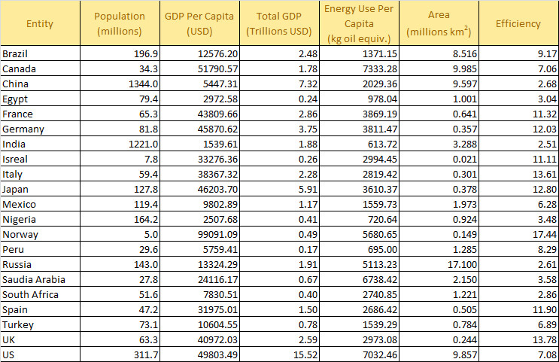

The data referenced to calendar year 2011 since that is the latest year where data were available for all 5 categories. GDP values have units of United States Dollars (USD). The unit of energy use per capita is [kilogram oil equivalent](https://en.wikipedia.org/wiki/Kilogram_oil_equivalent) (KOE), which is a normalized unit of energy that allows for world-wide comparisons.

To promote transparent discussions, each of the data points was obtained in the following way:

* Population and GDP values – Google search using ‘population <country name> 2011’
* Energy Use – Google search using ‘energy consumption <country name> 2011’
* Area – Google search using ‘area <country name> square kilometers’

where <country name> stands for one of the 21 names listed above.

The efficiency metric value is calculated as the ratio GDP per capita to energy use per capita and, as a result, has units of USD/KOE and state how much, in terms of goods and services, were produced per unit of energy.

## The Interpretation

Okay, with great data comes great responsibility. So how do we interpret the data responsibly? The first, and most obvious response, is to compare apples-to-apples. The easiest way to do this is to compare energy use per capita in a bar chart.

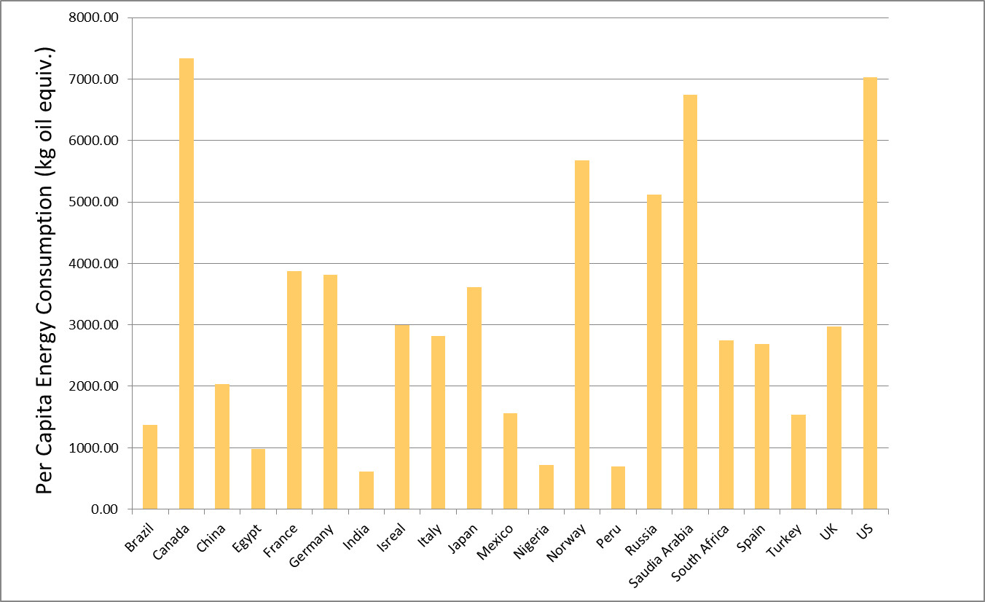

Perhaps surprisingly, Canada is the largest per capita consumer of energy in the sample studied. In 2011, Canada consumed approximately 7333 KOE versus the United States 7032 KOE. Saudi Arabia and Norway are close, consuming 6738 KOE and 5681 KOE, respectively. China, one of the world’s largest consumers of energy and one of the greatest polluters has a modest energy consumption of about 2000 KOE, two thirds less that the United Kingdom and about half of Japan.

But does this apples-to-apples comparison really tell us the full story? The answer is clearly no. What matters isn’t just how much of a commodity is consumed but also what is accomplished as a result of that consumption.

The situation has its analogy in basic family economics. It is one thing to spend (i.e., consume) $10,000 on a new roof and an entirely different matter to spend $1,000 on Pet Rocks. The first one is a larger expenditure, by a factor of 10 compared to the latter, but is clearly a better investment.

The most honest measure for what was produced by a country is the GDP per capita, taken as the value of all the goods and services made by the average citizen. There is no way to further evaluate the production beyond that since matters of cultural, societal, or philosophical valuation vary from person to person. The GPD measures, in some sense, what others in the market are willing to pay and nothing else. Nonetheless, it’s all there is.

This approach leads directly to the efficiency metric defined in the table above. When efficiency is displayed in a bar chart a much different story emerges.

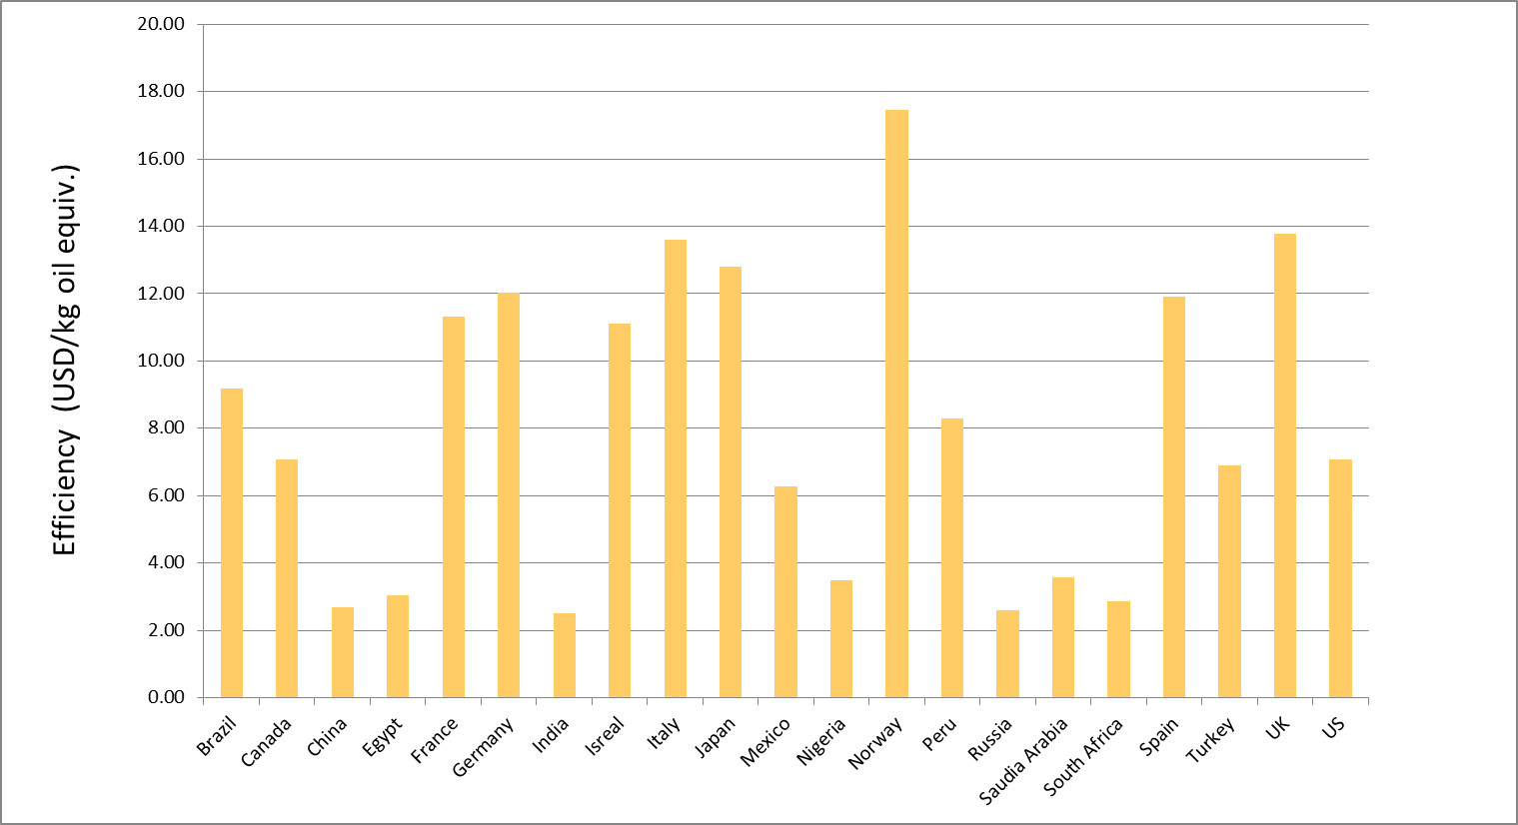

The United States and Canada each fall squarely in the middle of the pack, with their values of efficiency falling almost exactly on top of the median value for this sample.

At this point, the reader may be thinking that this is still not a true apples-to-apples comparison. After all, shouldn’t some adjustments be made for size and complexity of a country? The most obvious factors that I thought of that influence efficiency would be

* Climate (how hot or cold)
* Area (how big or small)
* Economic system (capitalist, social democracy, communist, etc.)
* Work force participation and training

Certainly a greater percentage of energy is consumed in colder countries compared to more temperate ones just to ensure the survival of the population, and this expenditure is not reflected in the GDP values. In addition, the amount of energy consumed for transportation is another expenditure that is not directly reflected in GDP. Finally, political forces shape the overall productivity of the work force either through the system of economic organization and/or through the percentage of able-bodied and trained citizens in the work force. The Soviet Union was notorious for having a very poor return on its energy expenditure even though it had immense resources.

Of these four factors, the only one that is relatively easy to work with is the size of the country in area, which is taken as a proxy for the size of the transportation expenditures. The following graph shows a scatter plot of efficiency versus country area.

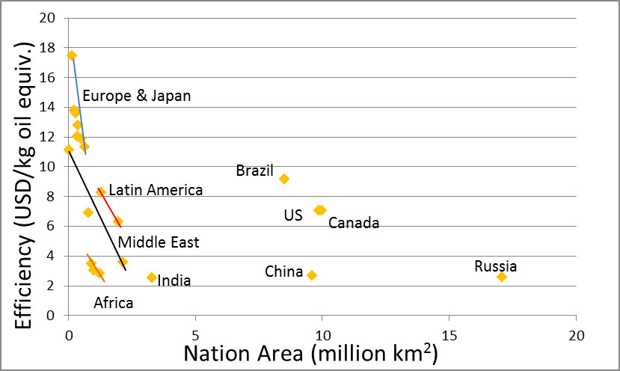

There are clear correlations between the size of the country and the efficiency, with the European (Norway, France, Germany, Spain, Italy, and the UK) countries and Japan topping the list. The Latin American countries (Peru and Mexico) also do pretty well although Mexico (with a 6.28 efficiency) definitely underperforms relative to its two neighbors to the north. For the most part the Middle East (Israel, Saudi Arabia, and Turkey) and Africa (Egypt, Nigeria, and South Africa) have terrible efficiencies well below the median, except for Israel, whose performance is indicative of the European countries.

For countries larger than 2 million square kilometers, only Brazil outperforms the United States and Canada. How much of this is due to climate is unknown but it is worth noting that Brazil has focused on energy efficiency and renewable energy sources in the past couple decades and some of that effort must be reflected in these numbers. Of course, it hasn’t been without a price as the cost of food in Brazil has risen over the years.

## Parting Thoughts

None of the analysis presented above is meant to defend the United States from the observation that energy is wasted. Most citizens in the United States pay only a little attention to how they consume energy since the cost to them is relatively small. It is clear that we can do better. However, it is also not the case that US citizens consume energy like a drunken sailor on leave spends money. Given the size of the nation, in both area and population, and the innovations and discoveries that originate here, the US makes a good return on the energy it consumes. In addition, the US produces the largest amount of oil and natural gas in the world, and is second in production of coal and the generation of electricity (<http://www.eia.gov/beta/international/>). It is patently unfair for intellectuals to continue to promulgate the myth that the US consumes energy at the world’s expense, a myth all the more dangerous since it is wrapped up in that innocent-looking little statistic that they like to throw around.

# Not all Inequality is Created Equal?

In a recent article in the Washington Post, blogger Ana Swanson reported on a new study in the field of economics that found some revealing and, perhaps, surprising results. The article, entitled, [*Why some billionaires are bad for growth, and others aren’t*](http://www.washingtonpost.com/news/wonkblog/wp/2015/08/20/why-some-billionaires-are-bad-for-growth-and-others-arent/), summarizes the findings of two economists, Sutirtha Bagchi of Villanova University and Jan Svejnar of Columbia University.

In their analysis, Bagchi and Svejnar, took [Forbes magazine annual list ranking the world’s billionaires](http://www.forbes.com/billionaires/list/#version:static), normalized the raw data to account for country size (either by GDP or by population or somehow – Swanson wasn’t particularly clear on this point), and then correlated the result with economic conditions in the country as a whole. According to Swanson, what the pair concluded was that as wealth inequality grew so did economic conditions for the general citizen worsen in the form of slower economic growth.

<They also found that their measure of wealth inequality corresponded with a negative effect on economic growth. In other words, the higher the proportion of billionaire wealth in a country, the slower that country’s growth. >

Also, the Bagchi and Svejnar correlated a percentage of the billionaires’ wealth to their political connections to the government. This measure of cronyism is supposed to help shed light on the positive and negative mechanisms that cause concentrations of capitol to exist in a country and that lead to wealth inequality. To illustrate this point, Swanson notes that the United Kingdom and Indonesia have similar [Gini coefficients](http://commoncents.blogwyrm.com/?p=83) (I found them to be 38.1 and 38.0, respectively, in the [World Bank Gini coefficient table](http://data.worldbank.org/indicator/SI.POV.GINI?page=1)) but that the business climate in these two countries are quite different.

The implication of this further analysis helps justify the title of the article – namely that not all concentrations of capitol come about for the same reasons and some billionaires are better than others.

In a nutshell, what Bagchi and Svejnar concluded were:

* [Gini coefficient](http://commoncents.blogwyrm.com/?p=83) doesn’t tell the whole story determining national growth
* Cronyism is a drag on the economy
* Innovation isn’t a drag on the economy

Wow! What a big surprise. I would never have seen that coming. Some billionaires actually deserve their fortunes because they enable rather than impede growth. To be fair, Bagchi and Svejnar didn’t actually state that billionaires who earned their money without political connections helped economic growth, simply that they didn’t impede it.

<“The negative effects of wealth inequality are largely being driven by politically connected wealth inequality. That seems to be the primary channel that drives this relationship,” Bagchi said in an interview.>

There are really two points that are worth addressing. The first one is on methodology. The second is on economic and philosophical outlook.

The methodology employed in the study requires one take the data with a grain of salt. For example, a few, simple queries of the Forbes list, Google, and the World Bank find the following data for Columbia and the United States.

|  |  |  |  |  |  |  |  |  |
| --- | --- | --- | --- | --- | --- | --- | --- | --- |
| Country | # of billionaires | Wealth Held ($B) | % Cronyism | GDP ($B) | Wealth held as % of GDP | Crony Wealth Held as % of GDP | Growth  Rate  (2013) | World Bank Gini Coefficient |
| [Columbia](http://www.forbes.com/billionaires/list/#version:static_country:Colombia) | 3 | 18.5 | 84 | 380.1 | 4.9 | 4.1 | 4.7 | 54.2 |
| [United States](http://www.forbes.com/billionaires/list/#version:static_country:United%20States) | 536 | 2564.4 | 1 | 18124 | 14.1 | 1.4 | 2.2 | 41.1 |

The data in this table do support the idea that the larger percentage of billionaires in the population the slower the growth as the percentage of billionaire-held wealth in the US is almost 3 times higher than that in Columbia. But that’s where the data stop making sense. Bagchi and Svejnar determined that 84% of the billionaire-held wealth in Colombia is due to political ties with the government. In other words, it is due to cronyism. In contrast, they found that only 1% of the billionaire-held wealth in the US is due to cronyism. Making the required adjustments, I found that ratio of Crony Wealth to GDP was 4.1% for Colombia versus 1.4% for the US and yet the Colombian GDP growth rate is double that of the US. Paradoxically, the Gini coefficient, which measures income inequality and is supposed to not be a reliable indicator of the harm that concentrations of capitol have on an economy, seems to be much more correlated with the Bagchi-Svejnar conclusion than their measure of ‘politically-connected wealth inequality’.

Perhaps the way that they chose to classify billionaire-held wealth is the problem. Well, I don’t have access to the original article so I can only quote what Swanson said

<So Bagchi and Svejnar carefully went through the lists of all the Forbes billionaires, and divided them into those who had acquired their wealth due to political connections, and those who had not. This is kind of a slippery slope — almost all billionaires have probably benefited from government connections at one time or another. But the researchers used a very conservative standard for classifying people as politically connected, only assigning billionaires to this group when it was clear that their wealth was a product of government connections. Just benefiting from a government that was pro-business, like those in Singapore and Hong Kong, wasn’t enough. Rather, the researchers were looking for a situation like Indonesia under Suharto, where political connections were usually needed to secure import licenses, or Russia in the mid-1990s, when some state employees made fortunes overnight as the state privatized assets.>

Now I’m not asserting that the Bagchi-Svejnar conclusions aren’t correct. They may be for all I know. I am asserting that there seem to be correlations that support some of their conclusions and others that don’t. Causation is another thing entirely.

Now on to the second point on the economic philosophy behind this whole revelatory study. Basically, these two economists claim to have discovered a data-driven conclusion that it matters how people get that wealth and how the government spends its money. In other words, that the basic neo-Keynesian idea about money and spending is wrong. That it is not enough for an economy to get money moving. [That is does matter if the work is productive](http://commoncents.blogwyrm.com/?p=182). That those who say “Go ahead and dig ditches even if you have to fill those ditches back up again. All that matters is that we’ve kept busy.” are wrong.

Of course, Bagchi and Svejnar may not say it quite that way but the conclusion is inescapable. For that matter, Ana Swanson may not say it that either but how else can one interpret the subtitle of her article ‘Not all inequality is created equal’!

# The China Syndrome

The year was 1979. Not a lot was known by the public about China, its people, its politics, or its economics. Nixon’s historic visit to the mainland had only happened about 7 years earlier and it was still a common occurrence to hear China referred to as Red China. On March 16th of that year, the movie entitled [*The China Syndrome*](http://www.imdb.com/title/tt0078966/?ref_=nv_sr_2) was released in theaters. The idea behind the movie was that negligence and corporate malfeasance at a nuclear plant led to a nuclear meltdown where the core metaphorically sinks through the earth all the way to China. Eerily, a scant 12 days later, [the accident at the Three Mile Island (TMI) plant](https://en.wikipedia.org/wiki/Three_Mile_Island_accident) in Dauphin County, Pennsylvania occurred. Suddenly, it seemed, all our worst fears about nuclear power were realized and the word ‘China’ had suddenly taken on a sinister meaning independent of the nation in the Far East.

Now with the benefit of hindsight, we can see that the TMI disaster, while serious, was not the catastrophic event that we feared. Even the far more serious nuclear accidents at Chernobyl and Fukushima-Daiichi have had little in the way of global impact. Simple analysis of the size of the stored energy in these plants relative to the size of the planet suffices to show that.

However, we are witnessing a meltdown of the Chinese economy and the impact of this event promises to have a global impact. Curiously, there weren’t any prescient tales speaking the precarious nature of the Dragon’s economy released to theaters. Not even a book that made it onto the best-seller list.

Just to set the stage, let’s consider for a moment where we were just a few short years ago and what the popular wisdom was. The common idea, spoken by pundit and plebian alike, was that the ‘Middle Kingdom’ was soon to be the dominant player on the world stage. The reign of the US dollar as the reserve currency has drawing to a close and soon the Yuan Renminbi would be what all the cool countries used.

I was deeply skeptical because I have a long memory and remembered the depressing and relentless drum beat of the 1970s and 80s heralding the United States’ economic doom at the hands of Japan.

<insert clip>

By the early 1990s, it was clear that strength of the Japanese economy had been exaggerated and the systemic weaknesses ignored. By the turn of the century, the world started talking about [Japan’s Lost Decade](https://en.wikipedia.org/wiki/Lost_Decade_(Japan)) and their economy has yet to recover from that slump, now roughly a quarter of a century later.

I can’t be certain why this cautionary tale was forgotten 10 years later, when economists were all agog with the ‘new economy’ engendered by the internet and the dot com bubble came and went. Nor why the message was lost again about 5 years later when almost everybody was considering flipping houses and the sub-prime bubble grew and burst.

All that is certain is that the message got lost once more – drowned in incessant chatter about the new powerhouse on the world stage. Never mind that China was following a ‘if you build it they will come’ strategy that piled up debt. Never mind that China played with it currency and subsidized oil purchases to keep gasoline costs low. Never mind that the Chinese government built entire cities in which no one lived. All that mattered to the intelligentsia was that the Dragon of the East had figured out what we in the West couldn’t – how to get around the law that says there is no such thing as a free-lunch.

Of course there were voices out there that said something was wrong, but they were in the minority and weren’t heeded then. Now you can’t hear anything else but words of woe on China.

So how bad is it and for long should we have known? It isn’t clear how to answer either of those two questions. By some measures China is much better off than other countries. Consider the following table that shows the ratio of Government Debt to GDP for select countries. Compared to the US and Japan, China’s central government hold significantly less debt (source: <http://www.tradingeconomics.com/>)

|  |  |  |  |  |  |  |  |  |  |  |
| --- | --- | --- | --- | --- | --- | --- | --- | --- | --- | --- |
|  | Government Debt to GDP Ratio | | | | | | | | | |
|  | **2006** | **2007** | **2008** | **2009** | **2010** | **2011** | **2012** | **2013** | **2014** | **2015** |
| **Country** |  |  |  |  |  |  |  |  |  |  |
| US | 63.3 | 63.9 | 64.8 | 76.0 | 87.1 | 95.2 | 99.4 | 100.8 | 101.2 | 103.0 |
| UK | 42.5 | 43.4 | 44.5 | 52.3 | 67.1 | 78.4 | 81.8 | 85.8 | 87.3 | 89.4 |
| Greece | 100 | 106.1 | 105.4 | 112.9 | 129.7 | 146.0 | 171.3 | 156.9 | 175.0 | 177.1 |
| Peru | 37.7 | 33.1 | 30.4 | 26.8 | 27.1 | 24.4 | 22.4 | 20.5 | 20.3 | 20.7 |
| Brazil | N/A | 56.4 | 58.0 | 57.4 | 60.9 | 53.4 | 54.2 | 58.8 | 56.8 | 58.9 |
| Germany | 68.0 | 67.6 | 64.9 | 66.8 | 74.5 | 80.3 | 77.9 | 79.3 | 77.1 | 74.7 |
| Japan | 175.3 | 172.1 | 167.0 | 174.1 | 194.1 | 200.0 | 211.7 | 218.8 | 224.2 | 230.0 |
| China | 33.8 | 31.5 | 34.8 | 31.7 | 35.8 | 36.6 | 36.5 | 37.3 | 39.4 | 41.1 |

But by other measures, China is in bad shape. According to Forbes Contributor Kenneth Rapoza, [its total debt to GDP ratio is approximately 280%. Is that bad, it’s hard to tell since the US’s total debt ratio is about 332%](http://www.forbes.com/sites/kenrapoza/2015/05/09/chinas-total-debt-load-now-over-280-of-gdp/). Further on, the same article has this to say about China’s growth in debt:

<…China led all emerging markets and was ahead of most developing markets in terms of an increase in total debt to GDP over a seven year period ending in the first half of 2014. Only Portugal, Greece, Singapore and Ireland saw their debt burden increase, but that is mainly due to massive corrections in economic output.>

Perhaps the most telling point is that China itself feels that it is in trouble. It took the unheard of step of adjusting its currency three times in a short period of time this summer. It also has been buying stock on its own exchange.

Will China fall? It is hardly likely. What is more likely is that its spend-now-and-pay-later expansion is coming to an end. China will still be an economic giant and that’s probably good, after all it has an incredible comparative advantage just due to population size. But it is very unlikely that it will ever dislodge the West from its pre-eminent position until it corrects its internal problems with liberty and human rights. Unfortunately, that isn’t a movie plot that can sell.

# Hernando de Soto

In doing the research for the previous post on [China and government held debt](http://commoncents.blogwyrm.com/?p=232) and the earlier one on [energy usage and wealth creation](http://commoncents.blogwyrm.com/?p=210), one country stood out – the country of Peru. It stood out not because it topped any particular list but because of the great strides that Peru has taken over the last quarter century to reform it government and economy. These reforms are reflected in the very low ratio of government held debt to GDP and in the relatively high efficiency with which it uses energy to create wealth.

During the 1980s, the situation in Peru was quite different. [Hyperinflation](http://www.businessinsider.com/worst-hyperinflation-episodes-in-history-2013-9#peru-july-1990-august-1990-7), which totaled in at an amazing 2,220,200% in the five year period from 1985 to 1990, was a crippling problem, social unrest lead to the rise of the Marxist [Shining Path (Sendero Luminoso)](https://en.wikipedia.org/wiki/Shining_Path), and the population had little to no faith in the government, dubbing even their president as [Alan ‘Crazy Horse’ Garcia](https://en.wikipedia.org/wiki/Alan_Garc%C3%ADa).

During the 1990s, Peru elected [Alberto Fujimori](https://en.wikipedia.org/wiki/Alberto_Fujimori) and his policies helped put the country on a stable trajectory and get its macroeconomic house in order. But how exactly did he accomplish this transformation? Well government is complicated and any success it enjoys has many creators but the Peruvian economist [Hernando de Soto](https://en.wikipedia.org/wiki/Hernando_de_Soto_Polar) played a big role.



de Soto was born in the Peruvian city of Arequipa in 1941 but was moved to Switzerland in 1948 following a military coup and the self-exile of his father a diplomat. When de Soto returned to Peru he found that the economic situation was appalling. In reaction to this, he founded the Institute for Liberty and Democracy (ILD) whose influence helped to enact over four hundred laws and regulations enabling the poorer members of Peruvian society to benefit from the having access to capital.

de Soto is perhaps best known for his experiments with the ‘stopwatch’. The idea behind his experiment is to determine how long it takes for a prospective entrepreneur to open a business. In other words, de Soto hopes to quantify the transaction cost required to become a legitimate business owner who operates within the law and enjoys the corresponding privileges, including formal recording of the title of ownership and well-defined protection of assets under the rule of law.

What he found was depressing. He tried to setup a small shirt factor and discovered that it would take 278 full days to get all of the permits needed and that, along the way, the would-be business man had to navigate a level of corruption where the bribe was the accepted currency. NPR recently aired [an engaging piece on de Soto’s efforts](http://www.npr.org/2015/02/05/384119672/how-corruption-affects-the-time-it-takes-to-do-business) which premiered on their Planet Money regular feature.

<iframe src="http://www.npr.org/player/embed/384119672/384119673" width="100%" height="290" frameborder="0" scrolling="no"></iframe>

As a result of his efforts, Peru has gone from the hyperinflationary times of the 1980s to a sustained average growth of approximately 6.6% for the last decade while simultaneously having a very low percentage of government-held debt to GDP around 20%.

Due to these successes, de Soto has been called upon by many foreign governments to help craft economic policies suited to the developing world. As a self-styled [‘third-worlder’](http://www.huffingtonpost.com/hernando-de-soto/piketty-wrong-third-world_b_6751634.html), de Soto maintains a fierce objection to the theses of many of the ‘western economists’ who publically maintain that there is too much capitalism in the world. He has been [powerfully critical of the general notion suggested by Thomas Piketty](http://www.independent.co.uk/news/business/comment/why-thomas-piketty-is-wrong-about-capital-in-the-21st-century-10251801.html) that capital causes friction between societal groups and that society should move away from such notions. de Soto convincingly asserts that Piketty engaged in [rash guesswork](http://www.independent.co.uk/news/business/comment/why-thomas-piketty-is-wrong-about-capital-in-the-21st-century-10251801.html) when analyzing the situation in the developing world and that [Piketty’s book *Capital in the 21st Century* represents Eurocentrism at is most extreme](http://www.independent.co.uk/news/business/comment/why-thomas-piketty-is-wrong-about-capital-in-the-21st-century-10251801.html).

The basic idea underlying de Soto’s analysis, is that there are really two types of economies in the world: legal and extra-legal. The world’s elite enjoy the benefits of working within the legal system – benefits that include most especially the right to their property. The rest of the world, some 5 to 6 billion, sits outside these protections. This group finds itself in the precarious position where the only protections they enjoy are arbitrary ones conferred locally by some microeconomic or microlegal structure. Go 2 miles in any direction and the protections vanish. Step one toe out of line and the protections vanish.

This lack of access to true capital, defined by de Soto as the formal recognition of property rights and all the protections implied by such a recognition, is what holds the poor down. He traces the self-immolation of [Tarek al-Tayeb Mohamed Bouazizi](https://en.wikipedia.org/wiki/Mohamed_Bouazizi), which led to the Arab Spring, to the expropriation of his property – that is to say by the arbitrary way in which this street vendor was robbed of his wares and his livelihood because he had no formal protection for his property rights.

<iframe width="560" height="315" src="https://www.youtube.com/embed/6RXdLYP-dxM" frameborder="0" allowfullscreen></iframe>

While he cares most about the poor in the developing world and for ways to lift them out of the extra-legal economy and into the legal one, de Soto also has some criticism for the West. He has sharp criticism for the lack of transparency in both Europe and the United States evident in the recent financial crisis.

<iframe width="560" height="315" src="https://www.youtube.com/embed/r-n3ux36Rz8?t=21m45s" frameborder="0" allowfullscreen></iframe>

I suppose de Soto see these tangled webs of toxic assets, credit default swaps, and derivatives as steps in the wrong direction; as ways in which the elite erode the property rights of many to enrich a few. I think he’s absolutely correct.

# Comfortably Numb

The year was 1979 and the rock band Pink Floyd had just released their concept album *The Wall*. Strains of *Young Lust* and *Another Brick in the Wall* filled the halls in my high school. These are fine songs (who can argue with lyrics like “How can you have any pudding if you don’t eat your meat!”?) but the song that really spoke to me was *Comfortably Numb*.

It emotionally resonated with me because beneath its seemingly depressing façade was a defiant and cautionary tale of the price that’s ultimately paid by numbing the pain rather than rising up against it and fixing the root malady.

I’ve always kept that message, if not exactly that song, near and dear to my heart. Bodily pain is the nervous system’s way of telling you something is wrong and numbing the body, except in the case of corrective action like surgery, is a foolish thing to do. By masking those important signals, you are tricked into thinking things are fine until catastrophe hits and a serious problem has now become an insurmountable problem. Tell most anyone in our wellness-conscious society and you’ll get a quick agreement – at least where the body is concerned.

The situation is quite different when it comes to the economic pain and, for reasons I can’t explain, very few people seem to know or care about the numbness that is killing our economy. And what is this anesthesia that is causing the numbness – the policy of the Federal Reserve to keep interest rates, specifically the discount rate, at zero.

In order to understand how low interest rates is acting to numb the economy, I need to say a little about prices.

In an economy, prices serve three purposes:

* Terms of the exchange for completing a transaction
* Signal to the producer about the relative worth of a good or service as judged by the consumer
* Signal to the consumer about the relative worth of a good or service as judged by the producer

When you go to a store and wish to purchase a good the deciding factor is the price. Measured relative to your want or need, the price determines whether the transaction is made and you leave the store with the item or the transaction remains unfulfilled and the good remains on the shelf.

Looked at locally, within the confines of a single consumer, the price simply serves to help determine the relative worth of the good to the consumer. Taken globally, each successful transaction sends a message from the consumer to the producer that the relative worth of the good is favorable to the consumer. Each failed transaction sends the opposite message, telling the producer that the good is valued too high. The speed with which the good is purchased sends a message about whether the price is too low or too high.

Likewise, each price set by the producer sends a message to the consumer about how the producer judges the worth of the good against the producer’s outlay in its production. If the producer can’t entice a consumer to buy the product for more than it cost the producer to make it then the message is sent that the producer should stop making the product.

In effect, the price system functions as the nervous system in the economy, sending messages to and fro between different parts of the body politic saying to either make more or less of a particular good. Seen in this way, prices help regulate the economy so that the scarce resources available to society are best used – where best is judged by consumer demand.

When the Federal Reserve keeps interest rates low, it basically floods the economy with an anesthetic that interferes with the signals sent using the price system. Businesses that should have received the message that they are not producing products desirable to society are instead receiving a mixed or muted message that tells them to try again.

By keeping interest rates too low, the Fed allows businesses that should have failed to remain on life support with what is essentially free money. The idea that the Fed has is that it is compassionate to keep business going; that in order for the economy to grow, businesses need to succeed.

But why? What’s wrong with failure as a message? In the body, pain speaks volumes. It tells the body not to do whatever caused the pain. Learning from the pain is not the same as preventing it entirely, for without the pain no growth can occur. How can our economy grow if we can’t learn what works and, more importantly, what doesn’t?

Maybe the Federal Reserve should read less and listen to some Pink Floyd instead.

# A Flood of Hazards

Although the hurricane season for calendar year 2015 began on June 1 and ends on November 30, there really is no denying that the meat of the season falls in the middle to the latter end of that time span, particularly heating up (or is it raining down?) in late September if you are in the mid-Atlantic states.

They say all politics is local and so is best analyzed from that point-of-view. I don’t about how true that is but I do know that all weather is local and the local weather here in the mid-Atlantic region could be a lot better. As I am writing this post, Tropical Storm Joaquin is dumping lots of rain and the lights in my house have flickered a couple of times. Local television programming is festooned with crawlers that display a warning from the National Weather Service warning of the possibilities of flash floods.

Now, I don’t live in a flood zone but I am familiar with the struggles of those who do. I grew up in western Pennsylvania where floods were common and people I knew routinely lost personal property, entire houses, and even their lives, when the rivers crested above their banks. I am sympathetic to the poor and lower-middle class who were forced to near the rivers since that was where cheap housing was available. And every kid who went to school in my day was told cautionary tales about the great [Johnstown Flood](https://en.wikipedia.org/wiki/Johnstown_Flood) in 1889 that killed over 2,000 people in that small town in central Pennsylvania when a dam failed after days of heavy rain.

We were also taught about the importance that wonderful safety net that is federally funded flood insurance to help those who live in flood zones and, therefore, need the protection. For many years, I believed that claim without any skepticism, subjecting it to no critical analysis but later in life I was introduced to the idea of a moral hazard that changed my outlook.

The National Flood Insurance Program (NFIP) was established in 1968 with the express purpose of protecting people by providing what private insurance could not – flood damage protection. Homeowners and businesses in these areas could obtain flood insurance under the program and over its nearly 50 year history, NFIP has paid out over $43 billion in claims to over 5.5 million people ([source](http://blogs.colgate.edu/economics/files/2014/09/McGee-2014-Moral-Hazard-and-the-National-Flood-Insurance-Program.pdf)).

Under the program, homeowners or business located in federally designated flood plains are [required to buy the insurance](https://www.washingtonpost.com/opinions/hold-strong-on-flood-insurance/2014/02/02/5305ac62-8ab5-11e3-833c-33098f9e5267_story.html), although the full burden of the premium is not typical born by the insured. According to Mary McGee of Colgate University, in her article entitled [*Moral Hazard and The National Flood Insurance Program*](http://blogs.colgate.edu/economics/files/2014/09/McGee-2014-Moral-Hazard-and-the-National-Flood-Insurance-Program.pdf), homeowners and businesses pay only 10% of the actual actuarial cost of the premium. [Other sources](http://www.cbo.gov/sites/default/files/cbofiles/ftpdocs/82xx/doc8256/06-25-floodinsurance.pdf) put the percentage paid closer to the 35-40 % range, but everyone agrees that the insured doesn’t foot the entire bill.

On the surface, this seems okay since the target group to be insured was originally conceived to be the economically disadvantaged who afford housing on safer ground. But because homeowners and businesses don’t bear the full cost of this risk, they are encouraged to build in flood plains. In other words, rather than assisting lower-wealth people who couldn’t settle on higher ground the NFIP encourages people on the higher end of the wealth scale to take risks that they would ordinarily shun because someone else bears the cost. This behavior is a textbook example of a moral hazard.

According to a [CBO report on the NFIP (page 2](http://www.cbo.gov/sites/default/files/cbofiles/ftpdocs/82xx/doc8256/06-25-floodinsurance.pdf)), about 40 percent of subsidized properties are worth more than $500,000 and approximately 12 percent are worth more than a million. Rather than protecting the most vulnerable amongst us, federally-subsidized flood insurance is promoting risky behavior by those in society who can easily afford to avoid it. Both the [Washington Post](https://www.washingtonpost.com/opinions/hold-strong-on-flood-insurance/2014/02/02/5305ac62-8ab5-11e3-833c-33098f9e5267_story.html) and the [New York Times](http://www.nytimes.com/2008/03/18/business/18hazard.html?_r=3&) have called attention to this in articles about the unintended consequences of the NFIP.

Even the stalwart champion of responsible governance, John Stossel, has admitted to the fact that his very expensive home was replaced on our dime by the NFIP

<https://www.youtube.com/watch?v=_9MYyNYTcsM>

In the course of that debate, the fundamental fact that surfaced that the NFIP encouraged people to build expensive homes on coastal property because they knew that, should they suffer a loss, they would be restored. This is exactly the trend found by a group at NOAA. In the article [*Normalized Hurricane Damage in the United States: 1900-2015*](http://www.nhc.noaa.gov/pdf/NormalizedHurricane2008.pdf), the authors point out

Unless action is taken to address the growing concentration of people and properties in coastal areas where hurricanes strike, damage will increase, and by a great deal, as more and wealthier people increasingly inhabit these coastal locations. – R. A. Pielke Jr. *et al*

So until such time as the moral hazard caused by the NFIP, each natural flood of water will be accompanied by an unnatural flood of dollars leaving taxpayer’s hands ending up in the hands of people who built in a flood zone because they didn’t bear the cost of such risky behavior.

# An Interesting Warning

A recent article by Larry Summers, entitled [The global economy is in serious danger](https://www.washingtonpost.com/opinions/the-global-economy-is-in-serious-danger/2015/10/07/85e81666-6c5d-11e5-b31c-d80d62b53e28_story.html), recently caught my eye. For those who don’t know, Lawrence (Larry) Summers is a professor at Harvard and served as the Secretary of the Treasury from 1999 to 2001. No doubt the inflow of cash into the treasury during his tenure, a fact many economists credit to the ebullient spirit associated with ‘the new digital economy’ and the automatic stabilizers in the economy, did much to give him a reputation as an economic seer. But generally, I tend to take what he has to say with a huge shaker of salt mostly based on such idiotic sentiments as

<https://www.youtube.com/watch?v=CDCllPoroqg>

This current ‘chicken little’ prophesy of doom is really no exception. Although, to ‘be fair’, he does make some valid points in some areas but the bulk of his analysis is repackaged Keynesianism, which, oddly enough, may actually work in the particular situation the global economy is in.

In a nutshell, Summers warning center on secular stagnation where slow growth in the developed world hurts the emerging markets which, in turn, hurts the industrial countries.

<The problem of secular stagnation — the inability of the industrial world to grow at satisfactory rates even with very loose monetary policies — is growing worse in the wake of problems in most big emerging markets, starting with China. – Lawrence Summers>

To support this claim, Summers cites the IMF’s revision of growth forecasts for the US, Europe, and China downward. On the surface, this seems to be a slam dunk of a pronouncement but looking under the veneer one should ask if the IMF foresaw the global financial crisis of 2008. If they didn’t, which I suspect they did not, why start believing them now?

Summers also cites a curious statistic to make us feel all scared inside about the slowdown in growth in China. He points out that China poured more concrete in the time span from 2010 to 2013 that the United States did in the entire twentieth century. This statistic, [which is explained in more detail here](http://www.gatesnotes.com/Books/Making-the-Modern-World), seems genuine but who cares. Again, without any context whereby the statistic is put on level footing it is hard to know what to make of it. During the bulk of the twentieth century concrete was not the chosen material for building. Only in the last third of that century did steel reinforced concrete really rise to a common building material, with granite and brick being much preferred prior to that time. A more meaningful comparison would have been to show how much the US used in the span between 2010 and 2013 and even then the comparison would be misleading as the US isn’t trying to catch up to the developing world nor is it trying to lift over a billion souls up to a higher standard of living almost overnight.

In another curious meandering of his thought made manifest in print, Summers writes

<History tells us that markets are inefficient and often wrong in their judgments about economic fundamentals. It also teaches us that policymakers who ignore adverse market signals because they are inconsistent with their preconceptions risk serious error. – Lawrence Summers>

Okay, which one is it Larry? Should we ignore the market because it is inefficient and often wrong about economic fundamentals or should we listen to the adverse signals that originate from it?

Sigh…

Despite all this intellectual-sounding fluff, the odd thing is that I think Summers has a point. Currently the amount of money in the economy is high and inflation is low. More dollars should be chasing the same amount of goods leading to growth and, perhaps, inflation. But it isn’t happening.

Summers doesn’t seem to venture a guess as to why but he comes close to a hint. He mentions that China is suffering from a hangover due to unproductive investment. What a surprise – a Keynesian actually suggesting that economic activity is not enough – that an economy needs to invest wisely.

And so finally, we arrive at the only useful nugget to be found in Summers’ analysis. Governments, businesses, and households all have to be prudent and wise in their investments. In the late 90s through to 2008, they were generally overly enthusiastic and made stupid investments and took on unsupportable debt. Post financial crisis, governments have layered even more burdensome regulation on the economy; regulations that they continually tinker with to show how responsible they are. Businesses are sitting on cash timidly afraid to take risk. Households have hunkered down and are waiting to see what their so-called leaders will do.

Someone has got to get the ball rolling again and perhaps Summers is right in saying that it is government that needs to do this. But if this is the case, then businesses and household need to be vigilant in making sure that increased government spending is done wisely. We don’t need anymore hangovers.

# The Gravity of a Minimum Wage

Some economists have argued for a long time that the establishment of a minimum wage would have a negative impact select segments of the economy or on society as a whole but there haven’t been controlled experiments that I am aware of that try to support this claim. That is up until now.

As of April of 2015, we may finally have a Petri dish in which to examine the role of price fixing in the labor market and we have a man by the name of Dan Price to thank.

Dan Price is the CEO of Gravity Payments, a Seattle-based credit card processing company of about 120 employees [1] who has decided to set an-across-the-board minimum salary of $70,000 for each of his employees.

According to the article by Riley and Harlow entitled [*Gravity Payments CEO defends $70,000 minimum salary*](http://money.cnn.com/2015/08/09/news/gravity-payments-dan-price-70k-salary/), Mr. Price had read a study that concluded that employees have substantial increases in their personal happiness until they reach a salary of $75K, after which the gains are less pronounced. Citing this study as motivation, Price then decided to unilaterally set the minimum salary resulting in significant raises for 70 employees, 30 of which will see their yearly earnings essentially double. To cover this expense, Price has cut his own salary from $1 million down to the minimum set by his own rule.

While the long-term results are yet unknown, the immediate results speak volumes about human nature, incentives, and the realities of the economy as Gravity Payments has seen some positive effects, some unintended consequences, and a heap of negative outcomes.

As cited in the [Business Insider article by Rachel Sugar](http://www.businessinsider.com/dan-price-gravity-payments-employees-leave-2015-7), some employees are ecstatic about the raise. One member said that the extra money would allow him to fly his mom from Puerto Rico to Seattle for a visit – something he was never able to do before because of the relative relationship between his earnings and the price of air travel. In addition, scores of new businesses have flocked to Gravity Payments due to what is viewed as their progressive stand. Sugar also notes that there may be some incentive for employees to work harder to justify their new, higher wages.

This kind of enthusiasm was no doubt anticipated by Price but other outcomes were no doubt unforeseen. In his article [*Why A $70,000 Minimum Salary Isn't Enough For Gravity Payments*](http://www.forbes.com/sites/davidburkus/2015/08/02/why-a-70000-minimum-salaries-isnt-enough-for-gravity-payments/), David Burkuspoints out that the company was inundated with emails, phone calls, and social media posts that have proved a distraction to the day-to-day operations of the company. In addition, they’ve been flooded with job application from people seeking employment in this brave new world.

But all of this is overshadowed by the strong, negative elements that resulted. The New York Times had a lengthy article entitled [*A Company Copes With Backlash Against the Raise That Roared*](,%20http:/www.nytimes.com/2015/08/02/business/a-company-copes-with-backlash-against-the-raise-that-roared.html) in which its author, Patricia Cohen, presents the responses of two key employees who quit over Price’s move.

One such employee is Grant Moran, a webdeveloper, who left Gravity Payments saying

<Now the people who were just clocking in and out were making the same as me. It shackles high performers to less motivated team members. – Grant Moran, former Gravity Payments webdeveloper>

More troubling is the story of Maisey McMaster, who Cohen describes as ‘one of the believers’ in Price’s business approach. McMaster join Gravity Payments when she was 21 and in her five years of employment had gain the position of financial manager by putting in long hours that left little time for her husband and her family. Originally onboard with the raises, she began to have her doubts. When she approached Price about her concerns she said he accused her of being selfish. She eventually quit Gravity Payments saying

< He gave raises to people who have the least skills and are the least equipped to do the job, and the ones who were taking on the most didn’t get much of a bump. – Maisey McMaster, former Gravity Payments financial manager>

Other negative side effects have included clients who left due to worries about the prospect of higher fees that they believe will be needed to cover the increased labor costs or because of the discomfort of the political statement they perceived. In addition, Price has alienated segments of the Seattle entrepreneur set who see this move as setting a dangerous precedent. Steve Duffield, the chief executive of the DACO Corporation, is quoted as saying

<We can’t afford to do that. For most businesses, employees are the biggest expense and they need to manage those costs in order to survive. – Steve Duffield>

Those are the facts. But what to make of them. As Riley and Harlow note, Price thinks any company can match his model but does that really make sense?

First, let’s take a look at that ecstatic employee with the mother living in Puerto Rico? Would he really be able to fly his mother into Seattle if everyone in the United States had a $70K minimum salary? Of course not! The cost of plane travel would also have to increase to cover the higher labor associated with pilots, mechanics, flight attendants, and service workers.

How about the large marginal increase in happiness as a result of the higher salaries. Here there are two sides to examine. For the employees who receive a huge bump up it isn’t at all clear that happiness will follow. As Sugar points out, many have begun to worry that their performance doesn’t merit the extra money. They will obviously split into two sets – the first rising to the occasion and working even harder and the second taking their windfall as a gift and changing nothing associated with their work ethic. Will the first set be happier? Maybe…but it is likely that some of them will long for the days where they had less money and fewer responsibilities. Those in the second set will then antagonize those who are actually earning the money, especially those who didn’t receive much of a bump in the first place. In addition, it is a reasonable concern to wonder if the minimum salary is simply too much money too early in the careers as many of the employees are 30 and under. Doesn’t this minimum salary hurt their competiveness in the labor market should they want or need to move to ‘less progressive’ companies? After all, it is reasonable to suppose that the gains in happiness that correlated with the rise in salary to $75k were as much a product of the employee’s achievement – the realization that they were ahead of their peers through fruits of their efforts. Also to what hope of future success can the employee look if there is nowhere else to rise?

Burkus suggests that the way to understand this dynamic is through the [equity theory of motivation](o%09https:/en.wikipedia.org/wiki/Equity_theory) as proposed by the organizational psychologist J. Stacey Adam. According to equity theory every employee in an organization is always analyzing their outlay in effort against what they get in return in relation to what others are doing. This model fits the complaints leveled by Moran and McMasters that led to their departure from Gravity Payments.

So with all this negative outcome, why did Price do what he did? Steve Tobak grapples with this question in blog for Entrepreneur entitled [The Sad Saga of the $70,000 Minimum Salary Company](http://www.entrepreneur.com/article/249313). To summarize, Tobak thinks Price acted impulsively without considering he bad incentives he would be instilling. I, however, have a much more cynical interpretation. As discussed in the Times article, Lucas Price, Dan’s brother, and co-owner of the business filed a suit prior to this minimum salary initiative citing that

<Dan has taken millions of dollars out of the company for himself while denying me the benefits of the ownership of my shares, and otherwise favoring his own interests as the majority shareholder over my interests. – Lucas Price>

I can’t help thinking that this whole episode really comes down to sibling rivalry – a chance for Dan to stick it to Lucas in a way that Dan look like some kind of folk hero.

# Candy and Wealth

It’s that time of year again. Pumpkins festoon front yards. Horror movies abound in theaters. Candy is sold by the ton. And costumes, scary, sexy, and just plain crazy are purchased, modified, and tailored just for the bacchanalia of the that most weirdest of nights in the fall – Halloween.

But what can Halloween actually say about economics? After all, this is a column on economics, wealth, money, and time. Well it turns out that Halloween night, after the trick-or-treaters have returned with their loot, provides the ideal setting for playing a game that illustrates how trade builds wealth. The name of the game is called the candy trading game.

The basic mechanics of the game is as follows. Take the trick-or-treaters to a big room and ask them to sort their candy into piles of similar types: M&Ms with M&Ms, Kit Kats with Kit Kats, Spree with Spree and so on. Then ask them to value each of their pieces of candy on a scale of 1-10, with 1 being the least liked and 10 being the most liked.

Since the valuation of candy is an individual and subjective thing, most likely each participant will have a pile of favorites (say Snickers) and a pile of yucks (say Black Licorice Twizzlers). Given a mostly random distribution of candy that results from going door-to-door, each costumed candy collector will find that the value that they ascribe to their haul will be somewhere around the 5 mark.

Now, without adding or subtracting any candy, allow the make-believe menaces to freely trade with each other. Soon Lik ‘Em Aids will be changing hands for Black Cows; Pixie Stixs for Reeses’ Peanut Butter Pumpkins, and so on.

Finally, stop the trading (albeit temporarily) and ask the crew to reevaluate their stash. Generally, the results will show that all groups report an increase in the value of their candy holdings even though no candy has entered or exited the economic ecosystem. The increase in value is, or course, variable, but when this game is played in more controlled settings (say a classroom), the increases can be quite dramatic. Increases of 30 to 60 percent have been seen in all groups simply be re-arranging who has what.

This is perfectly expected. Anyone who has ever trick-or-treated, or has chaperoned those who have, know that a time-honored tradition upon returning home is to trade with each, eat what you like, and hold onto what you don’t (either until you can justify throwing it out or until you get desperate enough to eat it).

The only mystery and horror is why, when we grow up, are we confronted with businesses and governments hell-bent in stopping free trade. I guess devils can be found even outside Halloween.

Net Neutrality Picking Sides?

One of the

* Unintended consequences
  + Happen in all laws
  + Human activity, like water, finds ways of flowing around dams
  + Economic activity (is all activity economic?) is especially flexible
* Net Neutrality
  + What is it
  + Well-meaning or not, it has an unintended consequence
    - Net Neutrality and religion
* Freedom of association